L4-W5-DBS301-Group functions

*STEP 1: Put the SQL and the results after each question below*

*STEP 2: Submit on Blackboard.*

1 Display the difference between the Average pay and Lowest pay in the company.

Name this result *Real Amount*.

SELECT

TO_CHAR(AVG(SALARY),'$999,999.99') AS "Average pay",

TO_CHAR(MIN(SALARY),'$999,999.99') AS "Lowest pay",

TO_CHAR((AVG(SALARY)-MIN(SALARY)),'$999,999.99') AS "Real Amount"

FROM employees;

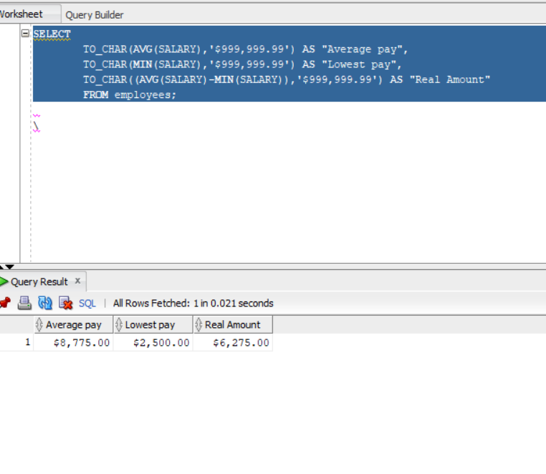

2 Display the department number and Highest, Lowest and Average pay per each department. Name these results *High, Low* and *Avg.*

Sort the output so that the department with highest average salary is shown first.

SELECT DEPARTMENT_ID AS "Department Number",

TO_CHAR(MAX(SALARY),'$999,999.99') AS "High",

TO_CHAR(MIN(SALARY),'$999,999.99') AS "Low",

TO_CHAR(AVG(SALARY),'$999,999.99') AS "Avg"

FROM EMPLOYEES

GROUP BY DEPARTMENT_ID

ORDER BY 4 DESC;

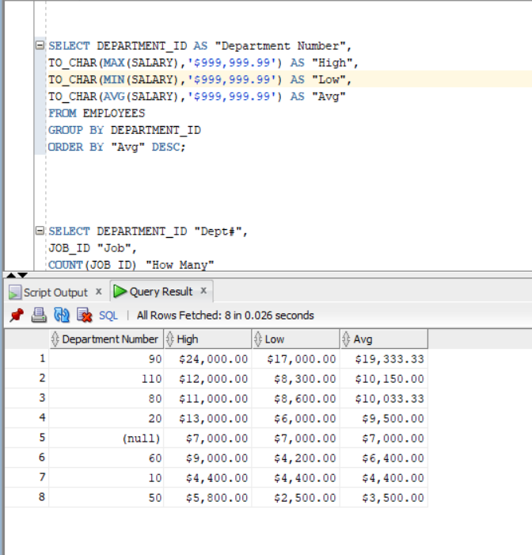

3 Display how many people work the same job in the same department.

Name these results *Dept#, Job* and *How Many.*

Include only jobs that involve more than one person.

Sort the output so that jobs with the most people involved are shown first.

SELECT DEPARTMENT_ID "Dept#",

JOB_ID "Job",

COUNT(JOB_ID) "How Many"

FROM EMPLOYEES

GROUP BY DEPARTMENT_ID, JOB_ID

HAVING COUNT(EMPLOYEE_ID) >= 2

ORDER BY 3 DESC;

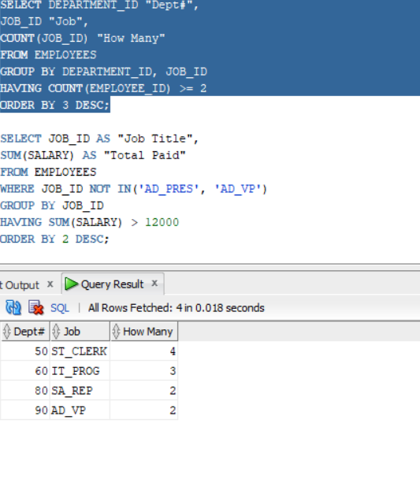

4 For each job title display the job title and total amount paid each month for this type of the job. Exclude titles *AD_PRES* and *AD_VP* and also include only jobs that require more than $15,000.

Sort the output so that top paid jobs are shown first.

SELECT JOB_ID AS "Job Title",

SUM(SALARY) AS "Total Paid"

FROM EMPLOYEES

WHERE JOB_ID NOT IN('AD_PRES', 'AD_VP')

GROUP BY JOB_ID

HAVING SUM(SALARY) > 15000

ORDER BY 2 DESC;

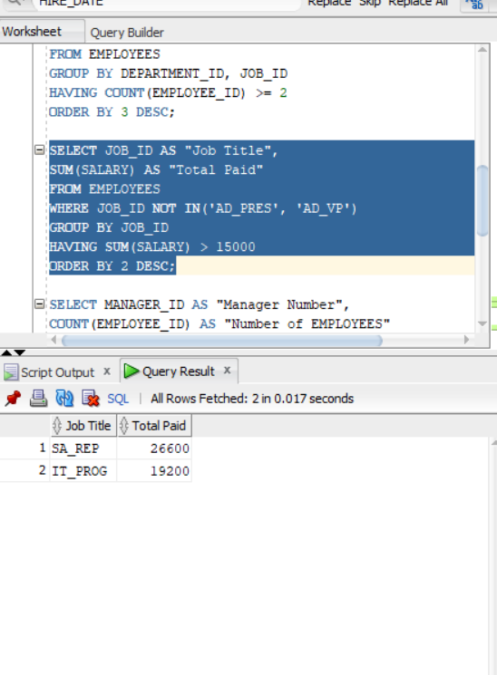

5 For each manager number display how many persons he / she supervises. Exclude managers with numbers 100, 101 and 102 and also include only those managers that supervise more than 2 persons.

Sort the output so that manager numbers with the most supervised persons are shown first.

SELECT MANAGER_ID AS "Manager Number",

COUNT(EMPLOYEE_ID) AS "Number of EMPLOYEES"

FROM EMPLOYEES

WHERE MANAGER_ID NOT IN(100, 101, 102)

GROUP BY MANAGER_ID

HAVING COUNT(2) > 2

ORDER BY 2 DESC;



6 For each department show the latest and earliest hire date, BUT

- exclude departments 10 and 20

- also exclude those departments where the last person was hired in this century.

- Sort the output so that the most recent, meaning latest hire dates, are shown first.

SELECT DEPARTMENT_ID AS "Department Number",

MAX(HIRE_DATE) AS "Lastest Hire Date",

MIN(HIRE_DATE) AS "Earliest Hire Date"

FROM EMPLOYEES

WHERE DEPARTMENT_ID NOT IN(10, 20)

GROUP BY DEPARTMENT_ID

HAVING TO_CHAR(MAX((HIRE_DATE)),'YYYYMMDD') < '20010101'

ORDER BY 2 DESC;

